Lab 3 - 3D Design for 3D Printing

In just three hours you will move from idea to first print, mastering the fundamentals of desktop additive manufacturing while solving a concrete engineering challenge: a front-mounted, servo-driven loader for the Arduino Alvik. Your design must anchor neatly to Alvik’s chassis, steer clear of its wheels and sensors, and repeatedly hoist a ~100 g payload without failure.

Armed with FlashForge Adventurer 5M Pro printers—capable of turning small STL files into parts in under an hour—you’ll prototype fast: export, slice, print, evaluate, refine. This rapid loop is the heartbeat of modern hardware development, and you’ll practice it here so it becomes second nature for future projects.

The loader you create can evolve into a tactical attachment for the forthcoming Sumo competition or seed a more specialized tool you’ll perfect later in the course. Either way, Lab 3 equips you with the print-oriented modelling habits, material know-how, and troubleshooting instincts that transform digital sketches into dependable, real-world hardware.

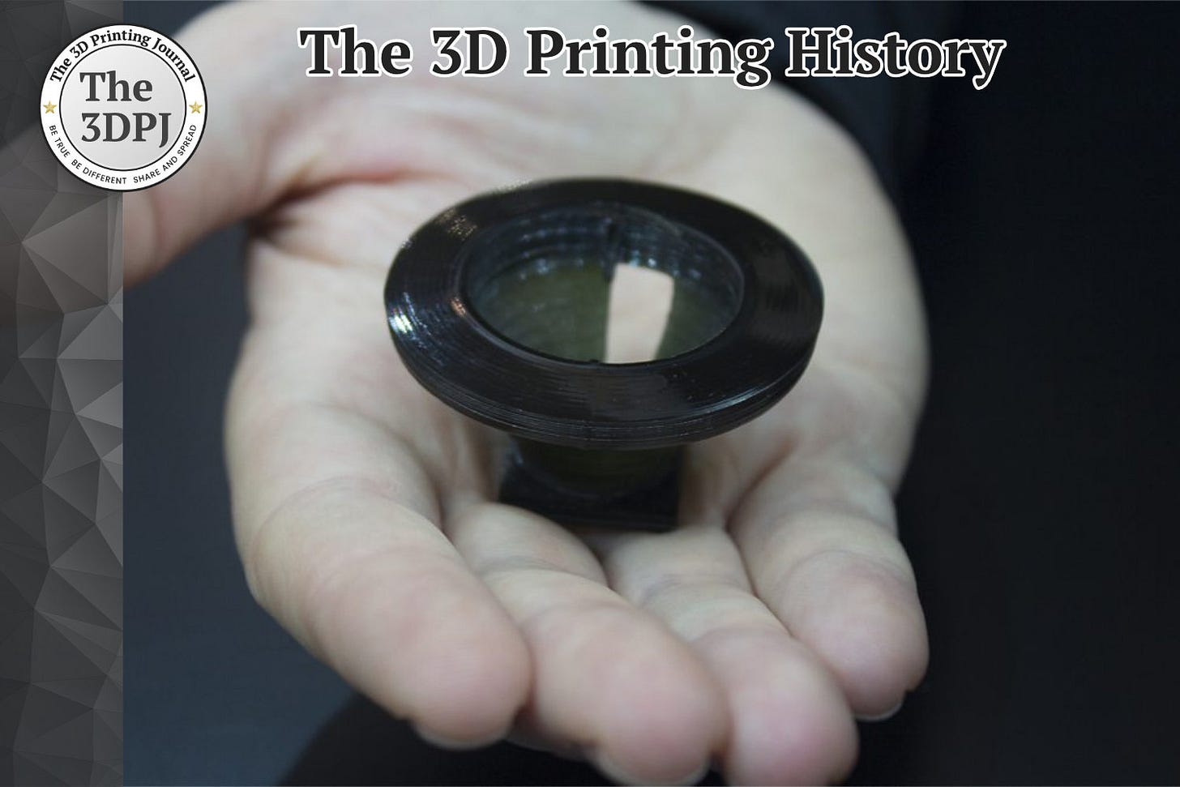

Figure : Figure 1: The first 3D-printed object (an eyewash cup, 1983) created by Chuck Hull using stereolithography <https://www.3dprintingjournal.com/p/03-09-1083-chuck-hull-created-the>

# 3D Printers History

3D printing (also known as additive manufacturing) emerged in the 1980s as a revolutionary way to create objects layer-by-layer. The first 3D printing technology was **stereolithography (SLA)**, invented by Chuck Hull in 1983. Hull created the first-ever 3D printed part – a small **eyewash cup** – by using ultraviolet light to solidify thin layers of liquid photopolymer resin. He filed a patent in 1984 and co-founded 3D Systems, which commercialized the **SLA-1** printer in 1987. Around the same time, other core technologies were developed: **Selective Laser Sintering (SLS)** was patented in 1988 by Carl Deckard at UT Austin, and **Fused Deposition Modeling (FDM)** was patented in 1989 by Scott Crump (co-founder of Stratasys). These three processes – SLA, SLS, and FDM – laid the foundation for modern 3D printing.

In the 1990s, 3D printing was adopted for industrial prototyping. High-end machines were expensive and used mainly by aerospace, automotive, and medical companies for rapid prototyping of parts. By the early 2000s, as key patents began to expire, 3D printing started to become more accessible. A major turning point was **2005–2009**, when Dr. Adrian Bowyer’s open-source [RepRap](https://reprap.org/wiki/RepRap) project (a self-replicating FDM 3D printer design) ignited a hobbyist community. Critically, the original FDM patent entered the public domain in **2009**, sparking an explosion of affordable, consumer-friendly 3D printers ([sculpteo.com](https://www.sculpteo.com/en/3d-learning-hub/basics-of-3d-printing/the-history-of-3d-printing/)). This led to the birth of companies like MakerBot and Ultimaker and a drastic drop in desktop 3D printer prices. By the 2010s, **desktop FDM printers** were widely available to hobbyists, educators, and engineers, ushering in the “maker” era of 3D printing. Today, 3D printing is a broad field encompassing numerous processes (plastic extrusion, resin curing, powder fusion, etc.) used for everything from home gadget fabrication to bio printing human tissues. The technology has evolved from its prototyping roots into an important manufacturing and creative tool across industries.

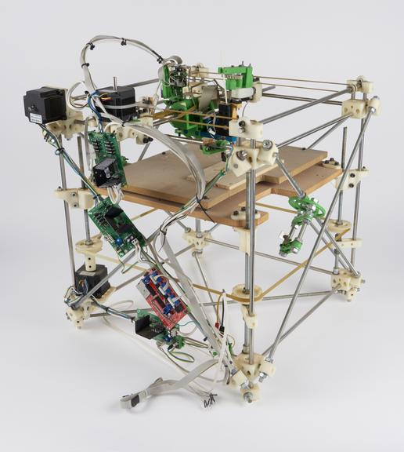

Figure : RepRap self-replicating 3D printer (Generation I), by Adrian Bowyer and Ed Sells, Bath University, 2007 <https://collection.sciencemuseumgroup.org.uk/objects/co8357315/darwin-reprap-self-replicating-3d-printer-generation-i>

# Common Additive-Manufacturing Technologies

There are **many 3D printing processes** in use today, each suited to different materials and applications. The most common additive manufacturing technologies include:

* **Material Extrusion (FDM/FFF):** Melts and extrudes thermoplastic filament through a nozzle, depositing material layer by layer. This is the technology used by most hobbyist printers (see Section 4). It’s great for affordable prototyping with plastics like PLA, PETG, ABS, etc., but layer lines are visible and very fine details are limited by nozzle size.
* **Vat Photopolymerization (SLA/DLP/LCD):** Cures liquid resin layer by layer using light. **SLA** uses a scanning UV laser, while **DLP** and LCD-based printers use projected light or a screen to cure a whole layer at once. These resin printers achieve extremely **high resolution and smooth surfaces**, making them ideal for detailed models, jewelry, dental aligners, etc. Downsides include messier materials (liquid resin) and the need for post-curing and support removal.
* **Powder Bed Fusion:** Uses a powder material (plastic, metal, or ceramic) and fuses it with an energy source. In **SLS** (Selective Laser Sintering), a laser sinters plastic powder (like nylon) to solidify each cross-section. The loose powder supports the part, so no added supports are needed, and complex geometries are possible. **Metal powder fusion** (DMLS/SLM) uses a laser or electron beam to fuse metal powders and can produce fully dense metal parts. These technologies are used industrially for functional prototyping and production (e.g., aerospace metal parts), but machines are large and expensive.
* **Material Jetting:** Works like an inkjet printer but jets droplets of photopolymer that are cured with UV light. This can produce full-color parts and very smooth surfaces. PolyJet (by Stratasys) is a common example. It’s used for realistic prototypes (like consumer product mock-ups with multiple colors or rubbery textures), but the photopolymer materials aren’t very strong for functional use.
* **Binder Jetting:** A liquid binder is selectively deposited onto a powder bed (sand, metal, or ceramic powder) to glue particles together layer by layer. The result is a “green” part that is later cured or sintered. Binder jetting can make sandcasting molds, or when used with metal powder and then sintered, can produce metal parts faster (though with some porosity). It’s valued for high speed and scaling to large build volumes.
* **Sheet Lamination:** Bonds sheets of material (paper, plastic or metal foil) cut in the shape of each layer. One example is **LOM (Laminated Object Manufacturing)** where adhesive-coated paper is cut with a laser and layered. This is less common today but can produce wood-like or paper parts.
* **Directed Energy Deposition:** Sprays powder or feeds wire into a laser or plasma arc to deposit material, usually metal, in freeform. It’s used for repairing or adding features to existing metal parts (e.g., repairing turbine blades) and for very large metal prints (as seen in some aerospace applications).

Each technology has unique **advantages and limitations**. For instance, filament extrusion (FDM) is cheap and versatile but tends to have the lowest resolution and mechanical anisotropy (weaker bonds between layers). Resin printing (SLA) yields high detail but materials can be brittle and not long-term UV stable. SLS can produce strong, durable nylon parts with no support structures, but machines are costly and the surface has a grainy finish. When approaching a design problem, engineers choose the process based on required material properties, part size, tolerance, surface finish, and cost constraints. In our lab, we focus on **Fused Deposition Modeling (FDM)** with thermoplastic filaments, as it’s the most accessible and safe for a classroom setting, but it’s valuable to be aware of these other additive methods that you may encounter in industry.

| **Technology** | **How it works** | **Typical use-case** | **Benchy-size cost (USD)** |
| --- | --- | --- | --- |
| **FDM / FFF (filament)** | Melts & extrudes thermoplastic filament layer-by-layer; visible layer lines. | Fast, low-cost concept models, jigs, hobby parts, education. | **$ 1 – 20** (material ≈ $1.2 + prep / service mark-up). ([weerg.com](https://www.weerg.com/guides/how-much-does-3d-printing-cost), [unionfab.com](https://www.unionfab.com/blog/2025/04/sls-3d-printing?utm_source=chatgpt.com)) |
| **SLA / DLP resin** | UV laser or projector cures liquid photopolymer in a vat—high resolution, smooth. | Dental casts, jewellery masters, cosmetic prototypes. | **$ 3 – 30** (resin ≈ $0.9; typical bureau minimums drive total up). ([blog.prusa3d.com](https://blog.prusa3d.com/how-to-calculate-printing-costs_38650/), [unionfab.com](https://www.unionfab.com/blog/2025/04/sls-3d-printing)) |
| **SLS (polymer powder-bed)** | CO₂ laser sinters nylon powder; unused powder self-supports parts (no support structures). | Durable functional prototypes, snap-fits, low-volume production. | **$ 20 – 50** (nylon powder $80–200 kg; service overhead). ([unionfab.com](https://www.unionfab.com/blog/2025/04/sls-3d-printing)) |
| **MJF (HP Multi Jet Fusion)** | Ink-jets fusing & detailing agents onto nylon powder then infrared sinters whole layer. | Fast small-batch end-use parts with near-isotropic strength. | **$ 10 – 30** (57 mm cube example fell from $29 → $3.8 when optimized). ([hawkridgesys.com](https://hawkridgesys.com/blog/understanding-elements-of-part-cost-for-hp-jet-fusion-3d-printing)) |
| **PolyJet (material jetting)** | Jets micro-droplets of UV-curable resin; cures immediately—multi-material & full-color. | Show-models, medical models, over-mould/look-and-feel prototypes. | **$ 120 – 150** (≈ $12 material + $119 tray/setup for a first-tray print). ([techfoundry.ucdavis.edu](https://techfoundry.ucdavis.edu/polyjet-system)) |
| **Composite FFF (Markforged Onyx)** | FDM with chopped-carbon-fiber nylon; optional continuous-fiber reinforcement for metal-like strength. | Strong jigs, fixtures, light-weight tooling. | **$ 20 – 50** (Onyx $0.27 cc → $4 material + prep & post ops). ([store.jacobshall.org](https://store.jacobshall.org/collections/vendors?q=markforged)) |
| **DMLS / SLM (metal powder-bed)** | High-power laser fully melts stainless, Ti, etc., powder to form dense metal parts. | Aerospace / medical prototypes, custom tooling, heat-resistant parts. | **$ 50 – 300** for a simple Benchy-sized part; metals start much higher than plastics. ([hlhrapid.com](https://hlhrapid.com/blog/metal-3d-printing-cost-guide/)) |

3DBenchy—the tiny tug-boat nicknamed “the jolly 3-D-printing torture-test”—was released in April 2015 by the Swedish company **Creative Tools AB** and modeled by **Daniel Norée** as an open, free-to-share STL file. You can grab the official file (and its multi-colour variants) from the project site’s download hub: [**3DBenchy.com/download**](https://www.3dbenchy.com/download/).

It became the de-facto benchmark because the 60 × 31 × 48 mm boat squeezes almost every common failure mode into a fast, low-cost print (~15 cm³): steep bow overhangs and cabin roof bridges expose cooling and support settings; the smooth, round hull reveals ringing or surface divergence; tiny embossed “#3DBenchy” letters and portholes test XY resolution; perfectly horizontal decks and a long, flat keel spotlight first-layer squish and warping; and the hull’s bilateral symmetry makes dimensional-accuracy checks easy with calipers. Because results are instantly recognisable—and thousands of printers share photos online—users can compare machines, slicers and materials at a glance, so the boat has evolved from an internal calibration part into perhaps the most-printed object on Earth.

For a hands-on FDM performance walkthrough that explains which Benchy features map to specific printer issues (stringing, z-banding, layer mis-alignment, etc.), see **All3DP’s “Troubleshooting Your 3D Printer with a Benchy” guide**: <https://all3dp.com/2/benchy-troubleshooting-guide/>

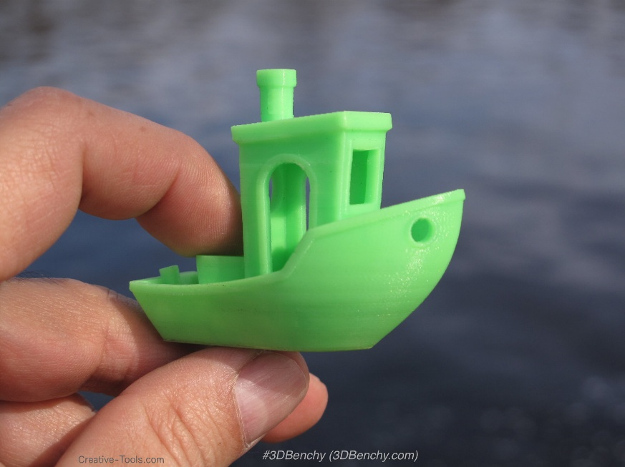

Figure : 3DBenchy <https://www.3dbenchy.com/gallery/>

# Fused Deposition Modeling (FDM)

**Fused Deposition Modeling (FDM)** is the most widely used 3D printing technology, especially for desktop printers. (Outside of trademark usage, it’s also called **Fused Filament Fabrication (FFF)** – the terms are equivalent.) The working principle of FDM is relatively straightforward and can be likened to a computer-controlled hot glue gun:

* **Thermoplastic Filament** (a long spool of plastic wire, typically 1.75 mm diameter) is fed into a heated **extruder head**. The extruder consists of a motor-driven gear (feeder) that pushes the filament, a heating element (hotend) that melts the plastic, and a fine nozzle (usually ~0.4 mm diameter) from which the molten plastic is extruded.
* The printer’s controller moves the extruder in **XY plane** to trace each layer’s cross-sectional shape, while extruding a thin bead of molten plastic. This material is deposited onto either a build platform or on top of previously printed layers.
* After completing one layer, the **build platform lowers** (or the print head raises) by a specified **layer height** (e.g., 0.2 mm), and the printer begins extruding the next layer. The plastic from the new layer fuses to the layer below it as it cools and solidifies.
* This process repeats layer by layer until the full 3D object is built.

Key characteristics and considerations for FDM include:

* **Materials:** FDM primarily uses thermoplastics. Common filaments are **PLA, PETG, ABS** (see Section 6 for comparisons), as well as others like TPU (flexible), nylon, polycarbonate, etc. Each material has different printing temperatures and behaviors (e.g., ABS tends to warp and needs a heated enclosure; TPU is flexible and prints slower).
* **Layer Adhesion:** Because FDM builds layer by layer, the strength of a print is anisotropic – layers are weaker in the Z-direction (perpendicular to layers) due to imperfect bonding. Cooling too quickly or printing too cold can weaken layer adhesion, whereas printing too hot can cause sagging. Proper temperature and sometimes an enclosure (to avoid drafts) help layers fuse strongly.
* **Supports and Overhangs:** FDM can only deposit material where there is something underneath to support it (either the previous layer or support scaffolding). **Overhangs** steeper than ~45° from horizontal typically require **support structures** (temporary material that is later removed). Unsupported horizontal bridges can only span a short distance (a few millimeters) before sagging[hubs.com](https://www.hubs.com/knowledge-base/how-design-parts-fdm-3d-printing/#:~:text=Key%20design%20consideration%3A%20Due%20to,processing). Good FDM design avoids large horizontal overhangs or uses arch shapes, chamfers, or support materials if necessary.
* **Resolution:** FDM resolution is governed by nozzle size and layer height. A standard 0.4 mm nozzle can print roughly 0.4 mm line widths. Typical layer thickness is 0.1–0.3 mm. Fine details smaller than the nozzle diameter won’t print well, and vertical features shorter than about 2 layers (~0.2–0.4 mm) may not form at all. As a rule of thumb, features should be several multiples of the layer height and nozzle width for reliability. For example, a **minimum wall thickness** of ~1.2 mm (roughly 3 extrusion widths) is recommended so walls print with at least 3 passes of the nozzle[3dsculplab.xyz](https://www.3dsculplab.xyz/KnowledgeBase/post/FDM-Design-Guide#:~:text=Minimum%20wall%20thickness).
* **Printing Speed:** FDM print speed is limited by how fast the extruder can melt and lay down plastic and by how quickly the plastic solidifies. Speeds of 40–100 mm/s are common for typical printers, though new “high-speed” CoreXY machines (like our FlashForge Adventurer 5M Pro in Section 5) can achieve much higher speeds with proper motion stability and input shaping. There is a trade-off: at higher speeds, **print quality** may suffer (e.g., ringing artifacts from vibrations, or inadequate cooling leading to blobby details).
* **Surface Finish:** FDM prints have visible **layer lines** on vertical surfaces. The layer lines are ~ the layer height in spacing, creating a *staircase* effect on curves. By printing at a finer layer height, the surface becomes smoother (at the cost of longer print time). Additionally, the top surface of an FDM print often shows the infill pattern or slight roughness, and the bottom (if printed on a flat bed) takes the texture of the build plate (often smooth glass or textured PEI). Post-processing like sanding or acetone vapor smoothing (for ABS) can improve surface finish if needed.
* **Calibration:** Achieving a quality FDM print requires calibrating several factors. The **bed must be leveled** (or auto-leveled) so the first layer adheres properly (neither too squished nor too loose). The nozzle **temperature** and **bed temperature** must be appropriate for the filament. Cooling fans are typically used (especially for PLA) to solidify the filament quickly after extrusion for sharper detail, except for materials like ABS that prefer a heated environment. **Extrusion flow** (steps/mm or flow rate) must be tuned so that the printer extrudes the correct amount of material – too little causes gaps, too much causes blobs. Printers often have test routines (like single-wall boxes or calibration cubes) to adjust these settings.

Despite these nuances, FDM remains extremely popular due to its **simplicity and affordability**. The printers are mechanically straightforward, materials are inexpensive, and there’s virtually no post-processing except support removal. FDM prints are well-suited for prototypes, enclosures, fixtures, and even end-use parts (when designed with the process’s limitations in mind). In this lab, you will gain hands-on experience with FDM by designing and printing a custom attachment, learning how to optimize your design for FDM’s strengths and avoid its pitfalls.

For rapid-iteration work we’ll use the **FlashForge Adventurer 5M Pro**, an enclosed, high-speed FDM printer that pairs classroom-safe ergonomics with surprisingly punchy performance. Its 220 × 220 × 220 mm build volume (8.7″ cube) is generous enough for full Halvik add-ons, yet the footprint remains desktop-friendly at 380 × 400 × 453 mm. A Klipper-driven motion system delivers up to **600 mm s⁻¹ print speed and 20 000 mm s⁻² acceleration**, while the swappable high-flow hot end reaches 280 °C—letting us run PLA, PET-G, ABS/ASA, TPU and even carbon-fibre blends. Quality-of-life touches include true one-click auto-levelling, a flexible PEI spring-steel bed heated to 110 °C, filament-run-out and power-loss recovery, a live-view camera, and a dual HEPA-13 + activated-carbon air-filtration path that keeps fumes in check—ideal for a teaching lab. Full specifications and manuals are available from FlashForge’s official datasheet:

<https://cdn-reichelt.de/documents/datenblatt/E200/FLASHFORGE_ADVENTURER_5M_PRO_DB-EN.pdf>

# ****PLA vs PETG****

In this lab we primarily print with two filament types: **PLA** and **PETG**. Both are popular, user-friendly plastics, but each has distinct properties. As a designer and fabricator, it’s important to choose the right material for your part. Here’s a comparison of PLA vs PETG and guidance on when to use each:

| **Criterion** | **PLA (Polylactic Acid)** | **PETG (Polyethylene-terephthalate Glycol-modified)** |
| --- | --- | --- |
| **Print settings** | 190–220 °C nozzle, 0–60 °C bed; enclosure not required | 225–255 °C nozzle, 70–85 °C bed; enclosure optional but helps with drafts |
| **Ease of printing** | Very forgiving: minimal warp, sticks to bare PEI or glue; ideal for beginners | Moderately easy: good layer adhesion but prone to stringing and blobs; bed prep (glue stick) prevents over-adhesion |
| **Mechanical behaviour** | Stiff and dimensionally accurate but brittle; tensile ~60 MPa | Tougher, less brittle, better impact resistance; tensile ~50 MPa, higher elongation |
| **Heat resistance (HDT)** | Softens around 60 °C—can deform in a hot car | Stable to ~80 °C; usable for light-duty functional parts outdoors |
| **Chemical / moisture resistance** | Poor against solvents; absorbs moisture slowly | Good resistance to water, alcohols, weak acids; dishwasher-safe when printed solid |
| **Surface finish & colours** | Naturally glossy; huge palette incl. silks, matte, wood, glow; sands & paints easily | Clear, translucent, or opaque gloss; fewer exotic blends; sanding harder (ductile surface) |
| **Environmental profile** | Bio-based and industrial-compostable; low VOC odour | Petro-based but 100 % recyclable (same polymer family as soda bottles) |
| **Typical spool cost** | ≈ 18 USD /kg for standard brands | ≈ 23 USD /kg for standard brands (≈ 30 % premium) |
| **When to choose** | Drafts, aesthetic mock-ups, fit checks, classroom projects where speed & cost trump toughness | Functional brackets, snap-fits, light mechanical parts, watertight housings, outdoor prototypes |

Source: [formfutura.com](https://www.formfutura.com/blog/material-guide-pla-vs-petg/) , [all3dp.com](https://all3dp.com/2/pla-vs-abs-vs-petg-differences-compared/)

**Summary:** For **most lab prints and beginner projects, PLA will be the default choice** – it’s easier to get good results and fine details, and there’s less to worry about in terms of settings. Use PLA for your first iteration or when printability and appearance are top priority. **Switch to PETG** when you need a part with more toughness, better heat resistance, or intended for outdoor use (for instance, an attachment that will see sunlight or a clip that needs to flex repeatedly). Be prepared to adjust settings for PETG and possibly clean up some strings. In terms of design, note that **dimensions can vary slightly** between PLA and PETG prints: PETG tends to shrink just a bit more, so holes or clearances might come out a tad tighter compared to PLA. A well-tuned printer can achieve dimensional accuracy with both, but if you’re making interlocking parts, keep tolerances (e.g., at least 0.2–0.3 mm clearance) to account for material differences.

From a mechanical perspective, **PLA has higher stiffness and tensile strength** in a pull test, but **PETG wins on impact strength, flexibility, and layer bonding**, yielding more durable functional parts. In our lab, we have both materials available. Feel free to print in PLA to quickly prototype your design, and if it needs more robustness, we can re-print in PETG. The printer (Adventurer 5M Pro) can handle both easily.

# FDM Design Guidelines

Designing parts for 3D printing requires understanding the constraints of the FDM process. Numerous “design guidelines” tables exist (from printer manufacturers, service bureaus, and community sources) that enumerate recommended minimum feature sizes, angles, clearances, etc. We have consolidated key points from **1 different design-for-additive guides** into the following distilled list of best practices for FDM design. Keep these in mind when creating your CAD models to ensure they print successfully and with good quality:

* **Minimum Wall Thickness:** Make walls sturdy enough. Aim for **≥ 1.2 mm thickness** (approximately 3 nozzle widths) for any load-bearing wall. Thin walls below ~1 mm may print as a single strand and are prone to snapping or not printing at all. Thicker walls also give the slicer room to infill with multiple perimeters, which improves strength.
* **Overhang Angle Limit (~45°):** Avoid designing overly steep overhangs. **Angles shallower than 45°** from horizontal can usually print without support, but anything **steeper (like 30° or flat)** will likely sag. If your design has an overhanging roof or feature, either add a gentle chamfer/fillet to raise the angle, split the part into two pieces that can be assembled, or accept that support material will be needed (and the underside will be rougher after support removal).
* **Bridging Span Limit (~5 mm):** Gaps that are “bridged” in mid-air can only go so far before the filament droops. Generally keep unsupported bridge lengths under a few millimeters. If a design requires a slot or hole through a horizontal surface, consider adding a slight arch or teardrop shape to shorten the span that is printed unsupported. For long bridges, the slicer’s bridging settings and cooling will matter, but design-wise, adding intermediate support ribs or splitting the part could help.
* **Clearance for Mating Parts:** Don’t model parts to fit exactly flush – always include clearance. A common rule is at least **0.2 mm gap on each side** for fitted connections, totaling **0.4 mm clearance** between components. For example, a 10 mm peg should go into a 10.4 mm hole. This accounts for slight material expansion and ensures parts don’t fuse together. For larger features or if you plan to post-process (sand, paint), a bit more clearance (0.5–0.6 mm) may be wise.
* **Over-sizing Holes:** Vertical round holes often print slightly undersized due to the way FDM layers tend to contract. A rule of thumb: add about **+0.4 mm to hole diameters** to compensate. For instance, if you need a 5 mm bolt to pass through, model the hole at ~5.4 mm. Alternatively, plan to drill out critical holes after printing.
* **Small Features & Pins:** Any freestanding pin or post should be fairly thick. **Minimum pin diameter ~3 mm** is recommended, with height no more than about 3× diameter for sturdiness. Slender pins or rods under 2 mm might not print reliably (they could wobble or snap off). For very fine posts, consider metal hardware instead or enlarge them if possible.
* **Embossed/Engraved Text:** For legible text on prints, stick to a **minimum stroke width of ~1.4 mm and letter height of ~2 mm**. Also use bold, sans-serif fonts. Embossed text (raised letters) typically turns out better than engraved (recessed) at small sizes, as engraved details can get lost if too shallow. A depth of at least **0.5 mm** is suggested for engraved text so it’s visible.
* **Tolerances & Accuracy:** Expect around **±0.5 mm general dimensional tolerance** on FDM parts. This means critical dimensions could be off by half a millimeter due to printer calibration, material shrinkage (~0.2–1% depending on filament), etc. So, avoid overly tight fits in your design – for press-fit pieces, it might require a bit of trial and error to get the right interference. If you need higher precision for something like a gear mesh or alignment feature, you may have to print test pieces and adjust accordingly.
* **Threads and Fasteners:** It’s challenging to 3D print fine threads. If you need threaded holes or studs, one approach is to **design for metal thread inserts** (e.g., heat-set inserts or hex nuts). Provide a cavity sized for the insert – for example, design a hole matching the insert’s outer diameter, often a tapered hole for heat-set inserts. Ensure at least **2 mm wall thickness around the insert** to give support. For larger printed threads (like a bottle cap), use rounded thread profiles (no sharp V-threads) and don’t go below ~M6 size. When in doubt, print the hole solid and **tap it manually**, or model a simple hexagonal pocket for a metal nut instead of printing the nut’s threads.
* **Sharp Corners vs Fillets:** Incorporate fillets/chamfers at bases of features. **Fillet the base of protruding features** (like bosses, tabs) to reduce stress and improve printability. Sharp, skinny bases might not adhere well or may snap off. Adding a fillet distributes stress and also gives more surface area on the layer for the feature to stick. Likewise, **chamfer edges that touch the build plate** (e.g., add a 45° chamfer 0.3 mm high at the bottom of walls) – this reduces the “elephant’s foot” effect (the slight ridge on the bottom layer due to first layer squish).
* **Avoiding Support Traps:** If your design has cavities or enclosed hollow spaces, make sure there is some way to remove support material if it gets generated inside. Try to orient the part or add drain holes so that support isn’t unreachable. Better yet, **design self-supporting angles or split the part** into pieces that can be printed without interior supports. For example, instead of a deep overhang, consider breaking the model into two halves that are later screwed or glued together, eliminating the need for internal supports.
* **Self-Alignment Features:** When designing multi-part assemblies to be printed separately, consider adding alignment aids. Simple **pegs and sockets** (again, with proper clearance) can help locate parts during assembly. If using screws, model pilot holes for them. Also, aim to orient each part in the print in an optimal way (flat base, minimal supports) – you can design the mating geometry accordingly. For instance, a flat interface between parts is easier to glue and often prints better as a top surface rather than trying to glue two rough support-undersides.

By following these guidelines, you’ll increase the likelihood that your 3D designs print successfully **on the first try** with minimal hiccups. In practice, every design is a bit of an iterative process: you might print a draft, discover that a clip is too thin or a hole is too tight, then adjust the CAD model. That’s perfectly normal in 3D printing – the goal is to incorporate these rules to reduce the number of iterations needed. In the lab, before you finalize your “tractor-loader” attachment design, use the above checklist: is every thin feature beefed up enough? Are holes and clearances accounted for? Have overhangs been given chamfers or supports? Taking the time in CAD to apply these **Design for Additive Manufacturing (DfAM)** principles will save you time later and result in a sturdier, more functional printed part.

## **Extended Read:**

| **Company – Guide** | **Brief description** | **Link** |
| --- | --- | --- |
| **Impact Labs – “The Complete Guide to 3D Printing” (Ch. 1)** | Explains what 3 D printing is, its historical roots and key benefits for newcomers. | [impactlabs.tech](https://www.impactlabs.tech/the-complete-guide-to-3d-printing-ch-1/) |
| **Rahix Blog – “Design for 3D Printing”** | Practical tips & rules of thumb the author gathered for reliably printable parts. | [blog.rahix.de](https://blog.rahix.de/design-for-3d-printing/) |
| **UltiMaker – “How to Design for FFF 3D Printing” (PDF)** | Step-by-step modeling advice (materials, tolerances, case study) for FFF/FDM machines. | [ultimaker.com](https://ultimaker.com/wp-content/uploads/2024/06/How-to-design-for-FFF-1.pdf) |
| **Prusa – “Modeling with 3D Printing in Mind”** | Knowledge-base article on overhangs, wall thickness, tolerances, manifold geometry. | [help.prusa3d.com](https://help.prusa3d.com/article/modeling-with-3d-printing-in-mind_164135) |
| **Formlabs – “Formlabs Design Guide”** | SLA-oriented guide detailing achievable feature sizes and resin-printing best practices. | [formlabs.com](https://formlabs.com/global/blog/formlabs-design-guide/) |
| **UltiMaker – “How to Design for 3D Printing: A Comprehensive Guide”** | 2025 deep-dive on orientation, supports, material choice, and design mindset shift. | [ultimaker.com](https://ultimaker.com/learn/how-to-design-for-3d-printing-a-comprehensive-guide-to-creating-3d-printable-designs/) |
| **Stratasys – “FDM Design Guidelines” (PDF)** | Four-page reference covering wall-thickness, warp, threads, clearance & orientation for FDM. | [stratasys.com](https://www.stratasys.com/siteassets/sdm/resources/design-guidelines/fdm/fdm_design_guidelines_2017-1.pdf) |
| **Markforged – “Composites Design Guide” (PDF)** | In-depth manual on feature sizing and continuous-fiber reinforcement strategies. | [static.markforged.com](https://static.markforged.com/downloads/CompositesDesignGuide.pdf) |
| **Autodesk Fusion 360 – “The Definitive Guide to Designing for Additive Manufacturing”** | 18-minute read (Mar 2025) blending DFAM theory, topology optimization & case studies. | [autodesk.com](https://www.autodesk.com/products/fusion-360/blog/the-definitive-guide-to-designing-for-additive-manufacturing/) |
| **Materialise – “Design Guides”** | Material-specific rules (min. wall, detail, clearance) for 20 + plastics, resins & metals. | [i.materialise.com](https://i.materialise.com/en/3d-printing-materials/design-guides) |
| **AON3D – “Design for Additive Manufacturing Guide”** | Concise article on tolerance tuning, overhang mitigation and strength improvements for high-temp FFF. | [aon3d.com](https://www.aon3d.com/hardware/dfam-guide/) |



Figure Design Rules for 3D Printing by PROTOLABS <https://www.hubs.com/get/3d-printing-design-rules/>

# 3D Design Software

To create the 3D models for printing, you will use **CAD (Computer-Aided Design) software**. There are many CAD and 3D modeling tools available, each with different strengths. Below are some popular software options for designing parts, ranging from beginner-friendly to professional-grade. You are encouraged to use whichever tool you are most comfortable with, as long as it can export a proper 3D file (usually STL or OBJ) for printing.

| **3 D Design Software** | **Commercial price / licence** | **Free for students?** | **Official link** |
| --- | --- | --- | --- |
| **Autodesk Fusion 360** | US $85 month or $680 year (full); personal-use version free | full features via Autodesk Education access | <https://www.autodesk.com/products/fusion-360> |
| **FreeCAD** | Free / open-source (LGPL) | already free | [https://www.freecad.org](https://www.freecad.org/) |
| **Onshape (Standard plan)** | US $1,500 year per user | Onshape Education plan is free | <https://www.onshape.com/pricing> |
| **SOLIDWORKS Student Edition** | US $60 year desktop licence | discounted student licence | <https://www.solidworks.com/product/students> |
| **Shapr3D Pro** | US $299 year (or ≈ $25 month) | one-year renewable Edu licence free | <https://www.shapr3d.com/pricing> |
| **Solid Edge Community Edition** | Free for hobbyists / makers | free downloads for students | <https://resources.sw.siemens.com/en-US/download-solid-edge-community-edition> |
| **OpenSCAD** | Free / open-source (GPL) | already free | [https://openscad.org](https://openscad.org/) |
| **PTC Creo Design Essentials** | From US $3,190 year locked licence | University Student Edition free | <https://www.ptc.com/en/products/cad/creo> |

For our Mechatronics Lab, we’ll **standardize on SOLIDWORKS** as the “house” CAD package:

* **Pre-installed in the lab** – All desktop workstations will have the latest SOLIDWORKS release so every student can jump straight into parametric modeling without extra setup.
* **Free student licence at home** – Tel Aviv University has a campus agreement with Systematics; you can request a one-year SOLIDWORKS Student Premium licence (renewable each academic year) using your TAU email.

# Model-Sharing Hubs

Sometimes you don’t need to design from scratch – you might find that someone has already created a 3D model of a part you need. Or you may want inspiration and examples to learn from. That’s where **online model-sharing repositories** come in. These websites host thousands (in some cases, millions) of user-uploaded 3D models, many of which are free to download and 3D print:

| **3-D model hub** | **What it’s mainly for** | **Cost model** | **Link** |
| --- | --- | --- | --- |
| **Thingiverse** | Maker-centric gallery of ready-to-print STL files—props, toys, brackets, cosplay, classroom projects (little or no editable CAD). | **Free** downloads; tips/donations optional | [https://www.thingiverse.com](https://www.thingiverse.com/) |
| **Printables (Prusa)** | Community site similar to Thingiverse but tightly curated; users share STLs plus slicer profiles and print photos. | **Free**; Prusameter reward system for designers | [https://www.printables.com](https://www.printables.com/) |
| **MyMiniFactory** | Curated “guaranteed-printable” models; strong on tabletop miniatures & art; mix of free and commercial STL packs. | **Freemium** (lots free, paid storefronts for creators) | [https://www.myminifactory.com](https://www.myminifactory.com/) |
| **Cults3D** | Marketplace for hobbyists where designers sell or gift STL files; frequent themed contests and brand collaborations. | **Free + paid** (designer-set prices) | [https://cults3d.com](https://cults3d.com/) |
| **CGTrader** | Large CG & 3-D-printing marketplace; files in STL, OBJ, FBX, STEP, etc. for art, product-viz and engineering concepts. | **Free + paid**; professional royalty options | [https://www.cgtrader.com](https://www.cgtrader.com/) |
| **TurboSquid** | Long-running pro repository for animation/visualisation; offers printable and non-printable models in many formats. | **Free + paid** tiers (price set by uploader) | [https://www.turbosquid.com](https://www.turbosquid.com/) |
| **Sketchfab** | Web-gl viewer and store; models viewable in-browser, downloadable as STL/OBJ/GLB; good for VR/AR assets and scans. | **Free gallery + paid store** | [https://sketchfab.com](https://sketchfab.com/) |
| **GrabCAD Community Library** | **Engineer**-oriented library of STEP, IGES, SolidWorks, Fusion, Inventor, etc.—assemblies, mechanisms, fasteners. | **Free** (requires free account) | <https://grabcad.com/library> |
| **TraceParts** | **CAD-supplier portal** with hundreds of catalogue parts (bearings, motors, profiles) in native and neutral CAD formats—ready for integration. | **Free** registration | [https://www.traceparts.com](https://www.traceparts.com/) |
| **NIH 3D Print Exchange** | Open biomedical repository—anatomy, molecules, lab hardware—STL & OBJ models derived from imaging data. | **Free / public-domain or CC-BY** | [https://3d.nih.gov](https://3d.nih.gov/) |

Model-sharing hubs are extremely useful for inspiration, collaboration, and sometimes for offloading part of the design work (no need to reinvent the wheel if a suitable wheel STL exists!). Just remember that downloaded models may still need adaptation to your specific needs or printer settings, and always verify dimensions if something needs to fit precisely with your design.

# **Artificial-Intelligence Tools**

The rise of AI is influencing 3D design and printing as well. While still an emerging field, there are **AI-powered tools** that can assist or automate parts of the 3D modeling process. Here are a few ways AI and machine learning are making inroads in 3D design, which might be relevant or interesting as you work on your project:

| **Company / Service** | **What the AI does** | **Typical output & audience** |
| --- | --- | --- |
| **Autodesk Fusion 360 — Generative Design** | Cloud solver explores thousands of geometry variants against mass, strength and manufacturing constraints; returns manufacturable CAD bodies or STL/STEP files. ([autodesk.com](https://www.autodesk.com/solutions/generative-design-ai-software)) | Mechanical engineers needing topology-optimised parts for CNC or additive workflows. |
| **nTop (nTopology) — Generative Design Workflows** | Field-driven latticing and multi-objective optimisation with full user control; scripts become reusable design “blocks.” ([ntop.com](https://www.ntop.com/software/capabilities/generative-design/)) | Advanced AM teams creating lightweight aerospace, thermal or energy-absorbing structures. |
| **SOLIDWORKS Cloud — Design Assistant** | ML model watches your habits, then auto-suggests mates, feature selections and repetitive edits; early generative-design “xShape” tools live on the same 3DEXPERIENCE stack. ([solidworks.com](https://www.solidworks.com/lp/evolve-your-design-workflows-ai)) | Desktop CAD users who want AI to handle tedium and speed assembly setup. |
| **Kaedim** | Converts one or more 2-D concept images into textured, game-ready meshes; human QC loop polishes tricky shapes before delivery. ([docs.kaedim3d.com](https://docs.kaedim3d.com/creating-assets/create-page)) | Indie and AAA game studios that need production-quality props fast. |
| **Luma AI — Genie** | Text-to-3-D diffusion model outputs GLB meshes from natural-language prompts in under a minute; free Discord bot for creators. ([parametric-architecture.com](https://parametric-architecture.com/luma-ai-unveils-a-new-text-to-3d-model-generator-genie/?srsltid=AfmBOoqlwqRUlvj8fMtcEqZ-G6ryptz3dGTWuR0XTVJsLbWvLb8j_1uq)) | Artists and product visualisers sketching ideas without traditional modelling. |
| **Meshy.ai** | Suite of Text-to-3-D, Image-to-3-D, AI texturing and auto-rigging tools; exports OBJ/FBX/GLB/STL and offers education discounts. ([meshy.ai](https://www.meshy.ai/)) | Game devs, XR builders and 3-D-printing hobbyists who want rapid asset iteration. |

For Lab 3’s scope, AI tools are not required, but you should be aware of them as part of the evolving landscape. If you feel adventurous, you might try a simple case – say, using an AI generator to create a basic scoop shape and then refine it in CAD. However, often it’s quicker to design directly using the CAD skills you’re learning, since our part has specific fit and functionality requirements. The AI won’t know our exact servo dimensions or mounting hole locations (at least not without a lot of guidance).

# Lab Task — “Tractor-loader” attachment for Arduino Alvik

Design, 3D-print and assemble a **front-mounted, servo-driven loader bucket** that projects in front of Alvik’s chassis yet keeps the wheels, bumper and downward-facing sensors completely clear. The attachment must repeatedly lift a **50 – 100 g** payload without tipping the robot forward, so pay close attention to the loader’s **center-of-mass** and keep heavy components (e.g., servos) as far back and low as practical.

Because our FlashForge Adventurer 5 M Pro printers can finish small parts in under an hour, you will print a first draft during the three-hour lab, and refine further iterations at home throughout the semester. The final design may serve directly in the Sumo competition or act as the chassis for a more specialized end-effector you’ll develop later.

**Design & Printing Guidelines**

| **Stage** | **Practical tips (PLA / PET-G on Adventurer 5 M Pro)** | **Why it matters** |
| --- | --- | --- |
| **1 Import official CAD** | Load the Alvik STEP assembly and side-view drawing (links below); use the Ø5 mm holes to anchor brackets and sketch the loader’s forward reach. | Ensures tyre & sensor clearance; avoids guess-and-check drilling. |
| **2 Split into modules** | Break the design into: ① left & right arms, ② bucket, ③ servo cradle(s), ④ cross-brace. Keep every part < 220 × 220 mm. | Faster prints, easier re-prints if one part fails, no tall supports. |
| **3 Orient for strength & balance** | Print arms flat (layer lines parallel to bending load); rotate the bucket 45 ° if the floor is thin. Mount servos **behind the bucket pivot**. | Aligns layers with stress and shifts mass rearward so Alvik won’t nose-dive. |
| **4 Self-supporting geometry** | Follow the **≤ 45 ° rule**: underside curves → 45 ° chamfers or tear-drops; minimum wall ≥ 1.2 mm (≈3 perimeters). | Eliminates supports, shortens print time, yields smoother undersides. |
| **5 Fastening & adjustability** | Model 3.2 mm pilot holes for M3 screws; add 0.2 – 0.3 mm XY clearance for PET-G parts. Provide slotted holes for servo-horn alignment. | Slide-fit assembly; no bench drilling; easy trimming of zero position. |
| **6 Servo integration** | Seat the servo horn just above Alvik’s top plate; drive the bucket via push-rod or direct horn **in-line with the arm**. | Lowers centre-of-mass, shortens wiring, minimises off-axis loads on the horn. |
| **7 Maintain serviceability** | Loader detaches with two screws; leave ≥ 5 mm clearance over ToF sensor and USB-C port. | Quick firmware flashing. |
| **8 Iterate efficiently** | **Drafts:** PLA, 0.28 mm layers, 15 % gyroid infill→ **Finals:** PET-G, 0.20 mm layers, 25 % infill. | One-hour draft cycles give rapid feedback; finals print in < 4 h and stay robust. |

**Resources**

**STEP model** – <https://docs.arduino.cc/resources/models/AKX00066-step.zip>

**Side-view drawing** – <https://docs.arduino.cc/static/f340ee41505d704954f5fef463db98d2/0f98f/Alvik_Docs_Dimensions_Side.jpg>

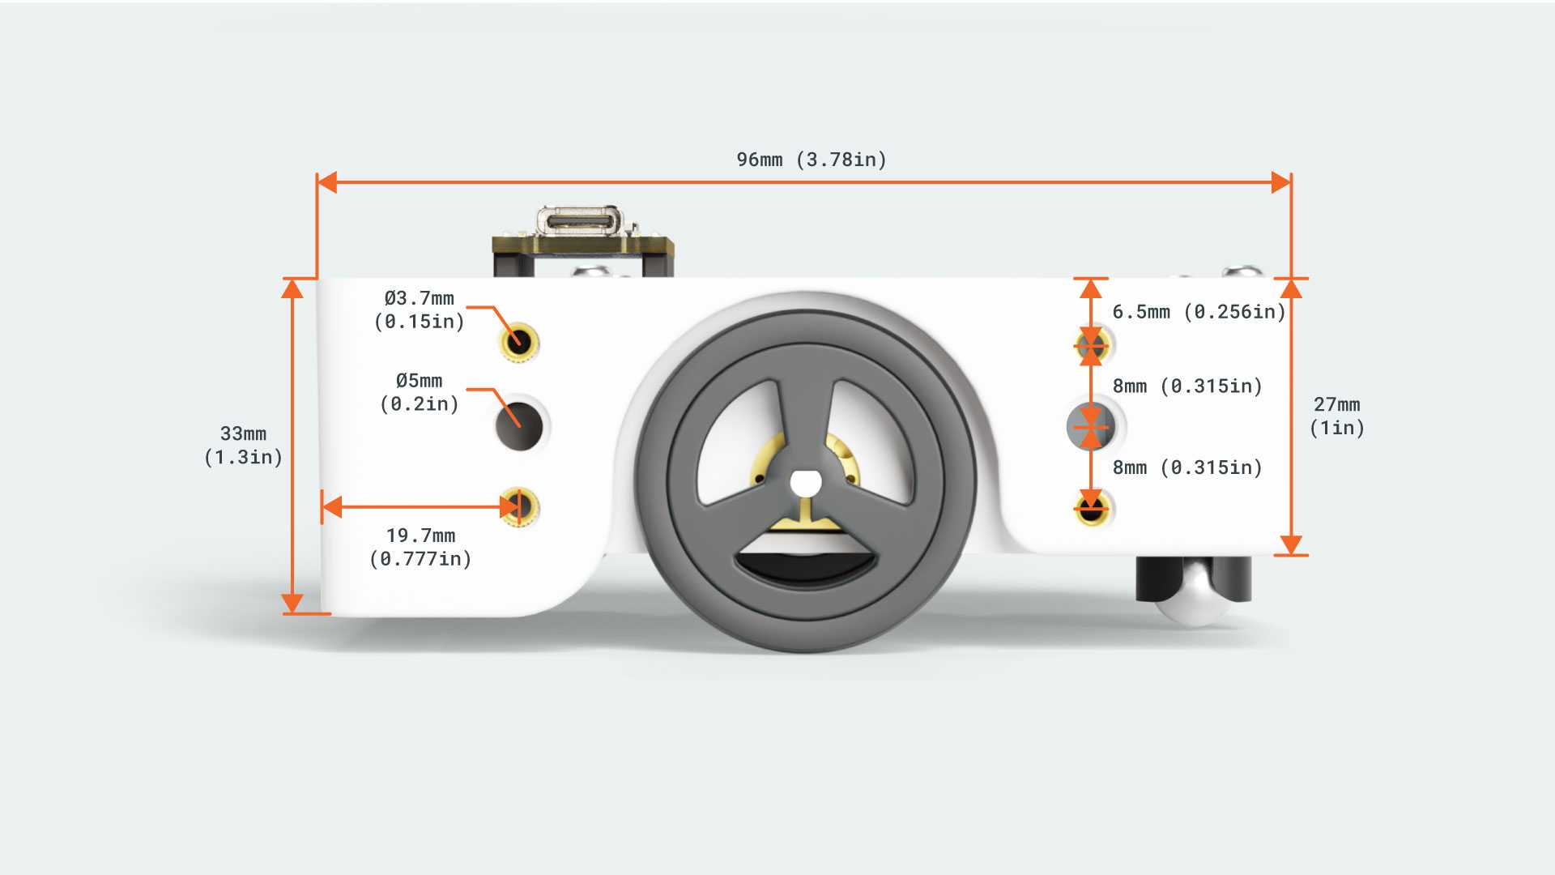

Figure : Alvik side view dimensions <https://docs.arduino.cc/static/f340ee41505d704954f5fef463db98d2/0f98f/Alvik_Docs_Dimensions_Side.jpg>

You will **begin the loader in Lab 3**, producing at least one PLA prototype before the session ends, then **iterate off-site**—tuning center-of-mass, fit, and actuation—throughout the semester.  
Whether you field it unchanged in the Sumo arena or adapt it into a specialized manipulator, this task cements the full rapid-prototyping loop: design → print → test → improve.

**For the Lab report:**

# Check‑Your‑Understanding Questions

1. **3D Printing History:** Who is credited with inventing the first 3D printing technology, and what was the **first 3D printed object** in 1983? Why was this development significant?
2. **Benchmark Models:** What is **3DBenchy** and why is it commonly printed when setting up a 3D printer? Name two specific printer capabilities that a 3DBenchy print can test.
3. **Additive Tech Contrast:** Briefly describe **one 3D printing technology** other than FDM (for example, SLA or SLS). How does its process differ from FDM in terms of materials and how layers are formed?
4. **FDM Constraints:** In FDM printing, what is the typical **maximum overhang angle** that can be printed without support, and what design feature can be used to accommodate overhangs that exceed this angle? (Provide the angle and one method like adding chamfers, supports, etc.)
5. **Printer Features:** The FlashForge Adventurer 5M Pro printer has a **CoreXY** mechanism and a HEPA/Carbon filter. What advantage does the CoreXY design give for high-speed printing, and why is the dual-layer air filter important in a classroom setting?
6. **PLA vs PETG Choice:** If you need to print a part that will be used **outdoors in the sun and subject to bending** (for example, a flexible clip on a garden tool), would you choose PLA or PETG filament, and why? In your answer, compare their relevant properties (UV/heat resistance and toughness).

# Post‑Lab Reflection Tasks

1. **Experience Summary (≤150 words):** Describe your overall experience designing and printing the loader attachment. What was one aspect that **surprised you** during the design or print (e.g., something that was easier or harder than expected)? And what was one **challenge or mistake** you encountered, and how did you overcome it?
2. **Design Documentation:** Include **labeled diagrams or images** of your final CAD design and the assembled printed loader on the robot. Provide a brief description of key features in your design. For instance, point out the hinge mechanism, how the servo connects, and how the attachment mounts to Alvik. If you made any design iterations, you can show the changes. (This can be presented as an annotated screenshot from your CAD program, with callouts.)
3. **“Design for FDM” Discussion (½ page):** Reflect on how you applied **design-for-3D-printing principles** in your project. Give at least two specific examples from your loader design where you considered FDM limitations or used recommended guidelines – and explain the outcome. For example, you might discuss how you adjusted a clearance for a moving joint and whether the printed fit was as expected, or how you added fillets to reinforce a part. Additionally, mention any feature that didn’t print as well as intended and what you might change in a future revision. This write-up should demonstrate your understanding of how theoretical guidelines translated into the actual print.